Concise Paper Title
  - author list (format: C. J. H. Dickens, G. Orwell, G. R. R. Martin)
keywords: three keywords describing the paper, separated by commas

Abstract
The abstract must convey the main content of the paper, as it will be used to select the papers that will be presented at the IWBE 2021. The abstract should be one or two A4 pages in length, may include figures and tables.
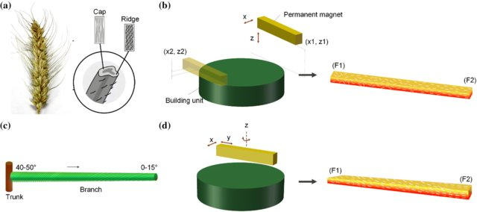
Figure 1: Bioinspired architecture for soft actuator design [2]
Please use the Word and LaTeX [1] templates available for the abstract, and submit the abstract as a PDF document at the EasyChair submission system via: https://easychair.org/conferences/?conf=iwbe2021
The abstract submission deadline is: June 30, 2021.

For further information about the IWBE 2021, please visit:
https://isbe-online.org/?ui=english&mod=info&act=view&id=4238

References
[1] Gratzer, G., Practical LaTeX, Springer, 2014.
[2] Ren, L. Li, B., Song, Z., Liu, Q., Ren, L., Zhou, X., 3D printing of structural gradient soft actuatorsby variation of bioinspired architectures, Journal of Materials Science, 54(8): 6542-6551, 2019.

