Concise Paper Title
  - author list (format: C. J. H. Dickens, G. Orwell, G. R. R. Martin)
keywords: three keywords describing the paper, separated by commas

Abstract
The abstract must convey the main content of the paper, as it will be used to select the papers that will be presented at the IWBE 2020 conference. The abstract should be one or two A4 pages in length, may include figures and tables.
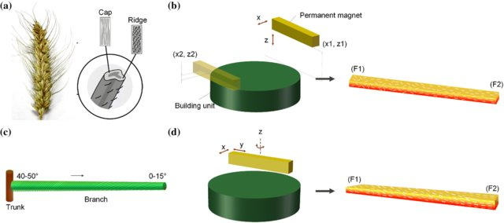
Figure 1: Bioinspired architecture for soft actuator design [2]
Please use the Word and LaTeX [1] templates available for the abstract, and submit the abstract as a PDF document at the EasyChair submission system via: https://easychair.org/conferences/?conf=iwbe2020
The abstract submission deadline is: 1st February 2020.

For further information about the IWBE 2020 conference, please visit:
http://isbe-online.org/?mod=info&act=view&id=3835

References
[1] Gratzer, G., Practical LaTeX, Springer, 2014.
[2] Ren, L. Li, B., Song, Z., Liu, Q., Ren, L., Zhou, X., 3D printing of structural gradient soft actuatorsby variation of bioinspired architectures, Journal of Materials Science, 54(8): 6542-6551, 2019.

